**Urban Aura Interiors Project Report**

**1.Project Introduction**

Introduction to the "Urban Aura Interiors" project.

Objectives and goals of the project.

**1.1 project overview**

Urban Aura is the Interiors are very well planners. They Construct a Building and Furnishing**.**

**1.2 Purpose**

The term "urban aura" is not a widely recognized or standardized concept, so its purpose may vary depending on the context in which it is used. In general, "aura" typically refers to a distinctive quality or atmosphere surrounding a particular place, object, or concept. When combined with "urban," it may pertain to the unique characteristics, ambiance, or energy associated with urban environments.

**2. Problem Definition and Design Thinking**

**2.1 Empathy Map**

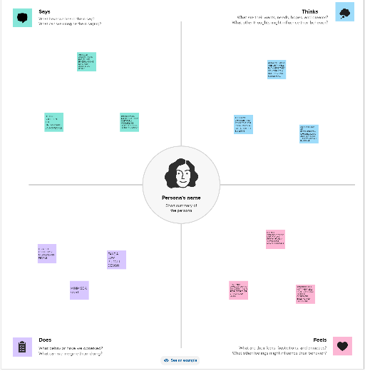

**2.2 Ideation and Brainstorm**

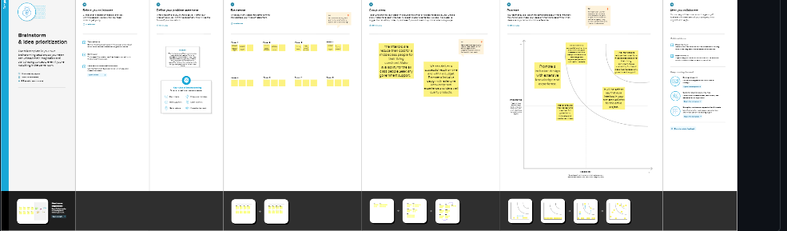

**3. Result**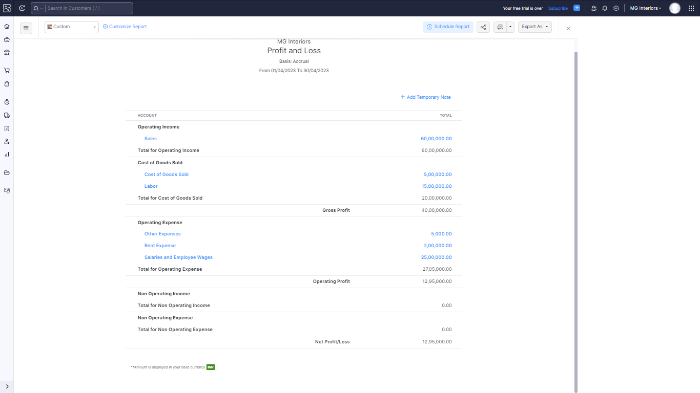

**4. Advantages and Disadvantages**

They give chances and ideas to their customers to got a perfect building.

Aura Interiors are reconstruct a office building and furnishing their workplace planning

It is not convenient to the middleclass people.

**5.Applications**

**Urban Planning and Design:** An "Urban Aura" project could involve designing urban spaces, including parks, streets, and public areas, to enhance the visual and sensory experience of city dwellers. This may include landscaping, street art, and architectural elements that contribute to the overall atmosphere of the city.

**6. Conclusion**

This program had been successfully executed.

**7. Future Scope**

Zoho develpement is going to focus on cloud service.

**8. Appendix**

A. Source code

https://github.com/gowsi3011/urban-aura